1. **Agenda**:
   1. Kind of authentication we want to configure.
   2. How the authorization should happen?
2. 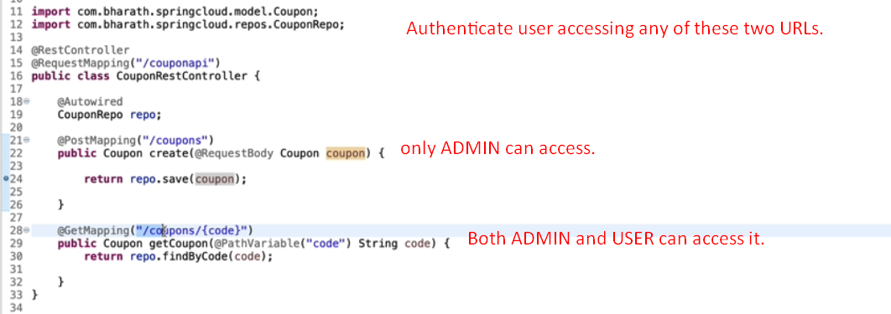
3. 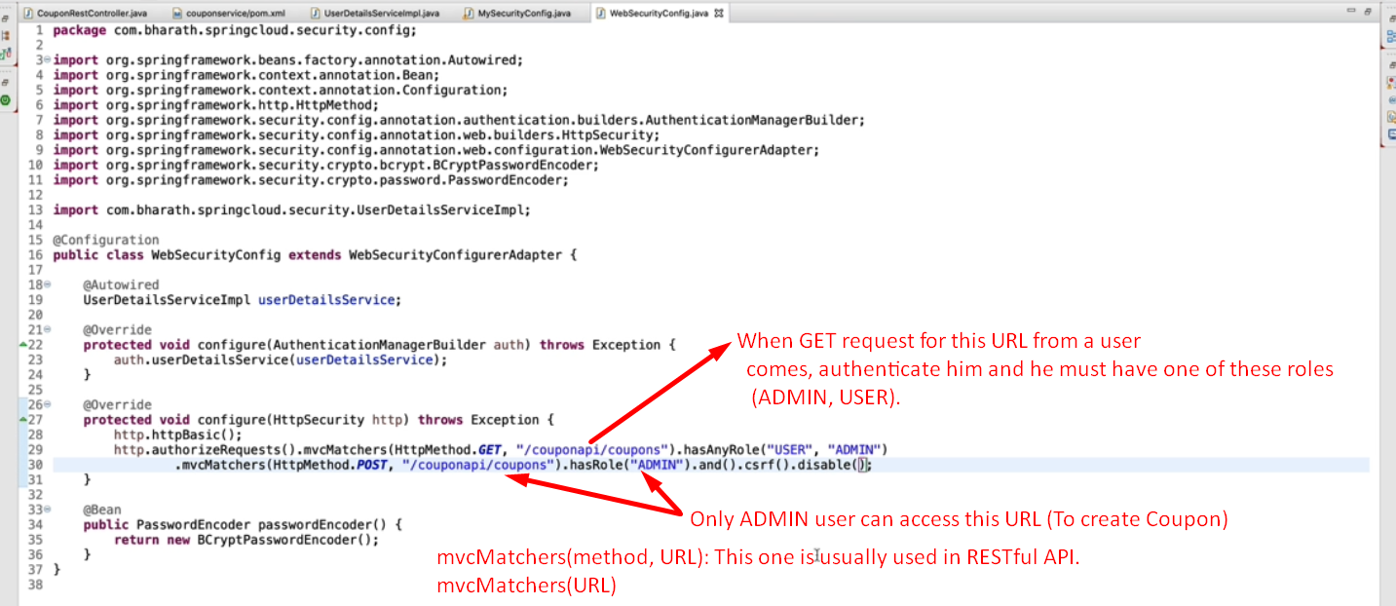  
   If we don’t pass any HTTP method to mvcMatchers() then it would be mapped to any HTTP methods.